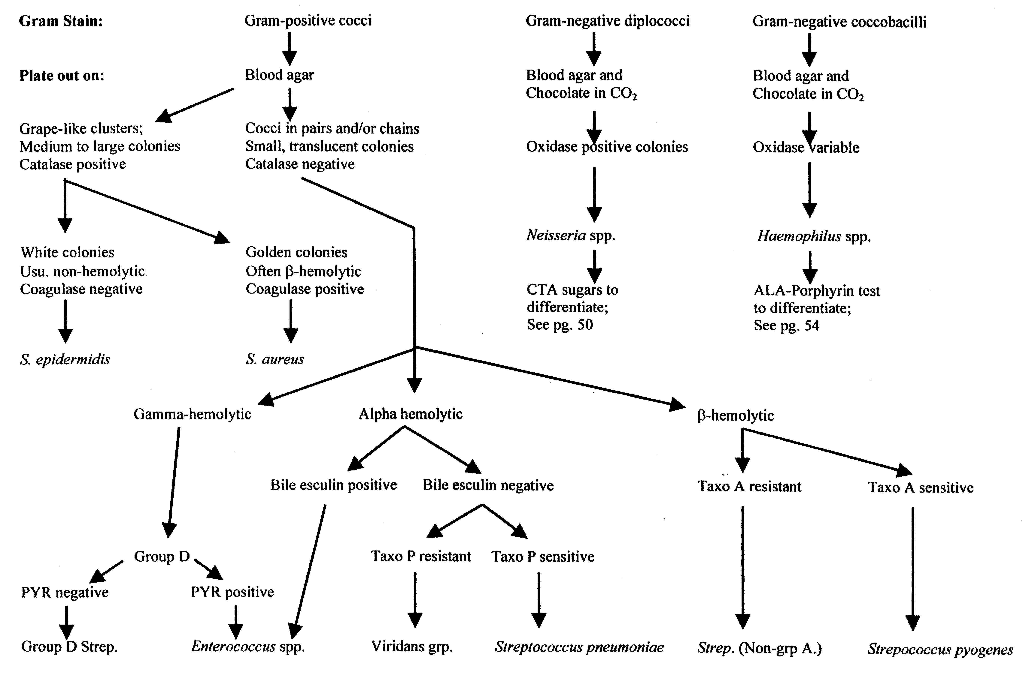
Flowchart A1: Differentiation and Characterization of Common Pathogenic Cocci

